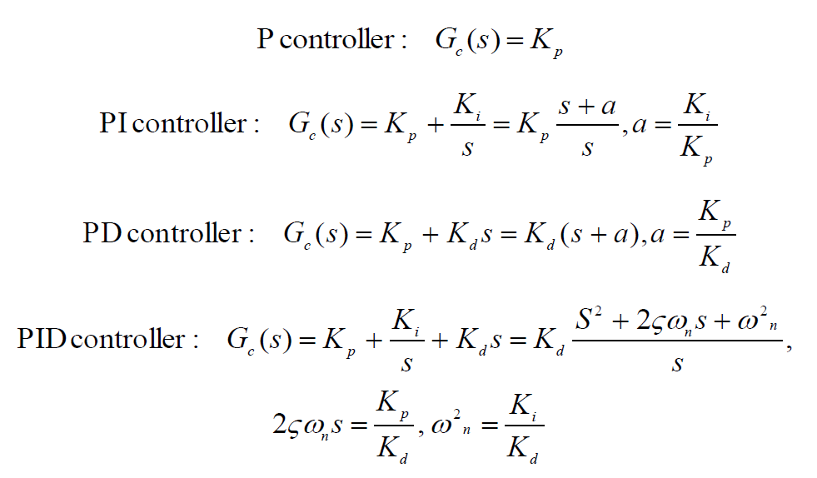

Temperature Curve Identified as a second order system:

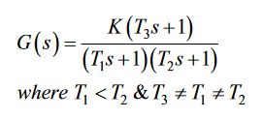

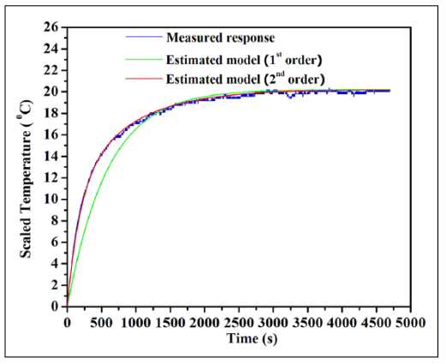

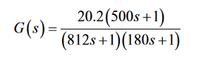

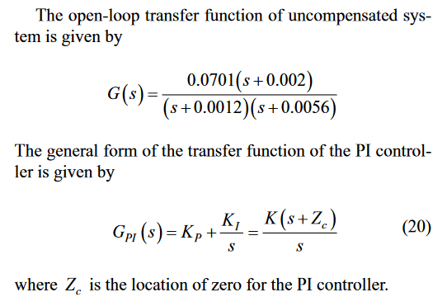

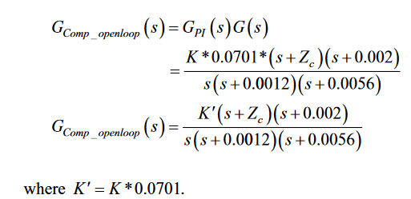

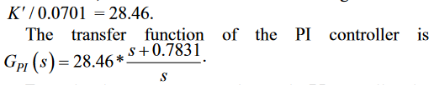

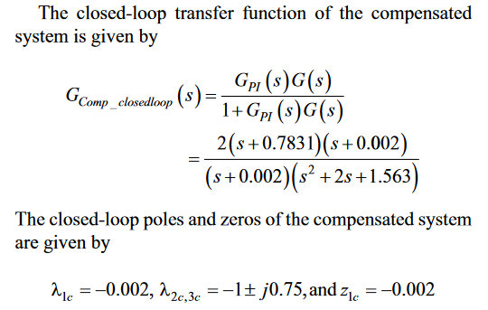

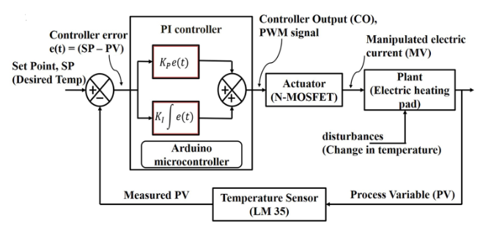

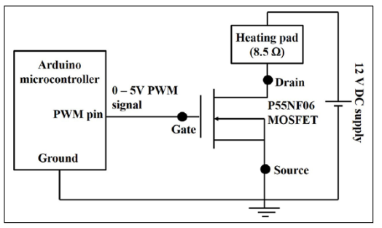

Discrete form of PI controller with anti-windup structure:

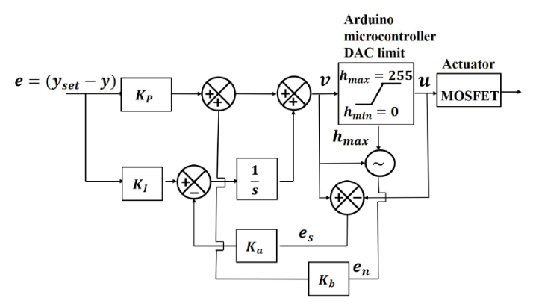

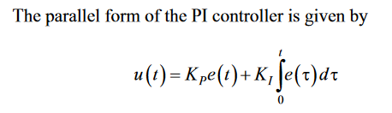



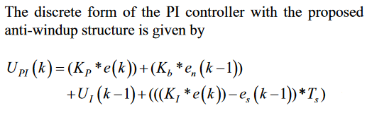

u(t) = controller output

KP is the proportional constant

KI is the integral constant

e(t) is the error where e(t) = u(t) – reference input

es is the error signal, the difference between the controller output, v, and the saturated controller output, u. It is 0 when there is no saturation (the feedback loop has no effect)

en detects disturbances and accelerates the proportional term for accelerated heat recovery

Ka is unity gain

Kb is the gain for en

TS is the sampling rate

Ka = 1

Kb = 0.5

ZC = 0.002

KP = K = 0.0701

KI = ZC * K = 0.0001402

TS = **sampling rate of attiny needs to be found**

**Final Equations:**

Ui(k) = Ui(k-1)+(((Ki*e(k))-es(k-1))*Ts)

Upi(k) = (Kp*e(k))+(Kb*en(k-1))+Ui(k)

UiPrevious is Ui(k-1)

esPrevious is es(k-1)

enPrevious is en(k-1)

**References:**

P. F. Khan, S. Sengottuvel, R. Patel, K. Gireesan, R. Baskaran, and A. Mani, “Design and Implementation of a Discrete-Time Proportional Integral (PI) Controller for the Temperature Control of a Heating Pad,” 2018. [Online]. Available: https://journals.sagepub.com/doi/pdf/10.1177/2472630318773697. [Accessed: 07-Feb-2021].